# D-flipflop

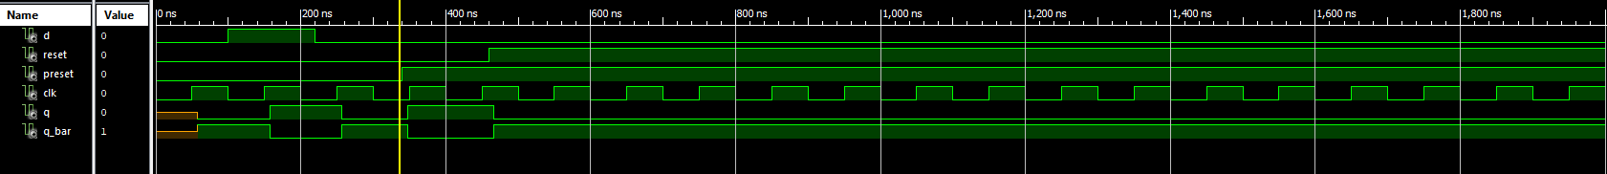

# Four bit Linear Feedback Shift Register



# N bit Register with LOAD/~HOLD control



# N bit Register with LOAD/~HOLD control and tristate output enable



# N bit Register



# N bit shift register with parallel load input



# N bit shift register



# N bit tri-state buffer



# N bit twisted ring counter



# N bit universal shift register

